# 

# 

# 

# Team Tetrahedron

Milestone #6 - Validation / Quality Control



Team members:

Lauro Fialho Müller

Chandan Radhakrishna

Raghava Vinaykanth Mushunuri

Kavya Vajja

Arnab Das

Anjan Chatterjee

16.06.2020

# Table of contents

1. Overview 1

2. Description, justification and results of the validation experiments 2

2.1 Experiment 1: Arrival Compare 2

2.2 Experiment 2: Sensitivity analysis 4

3. Any corrections made to your model or data 9

4. Limitations on the scope of the validity 10

5. Cost overview 10

6. Future work 12

# 1. Overview

In this milestone, the main idea is to ensure that the simulation program can be trusted. We computed the output from the model and compared them with real system output that is expected. We also performed validation experiments and tried to face-validate the model. While doing so we faced a lot of difficulties which is also discussed in the documentation.

# 2. Description, justification and results of the validation experiments

For the experiments, we have considered the following,

* Number of replications per iteration = 100
* Degrees of freedom = 99
* tVal = 2.87130765
* alpha = 0.005

## 2.1 Experiment 1: Arrival Compare

In this experiment, we measured the number of cars that are arriving in our simulation model at the source of each road.

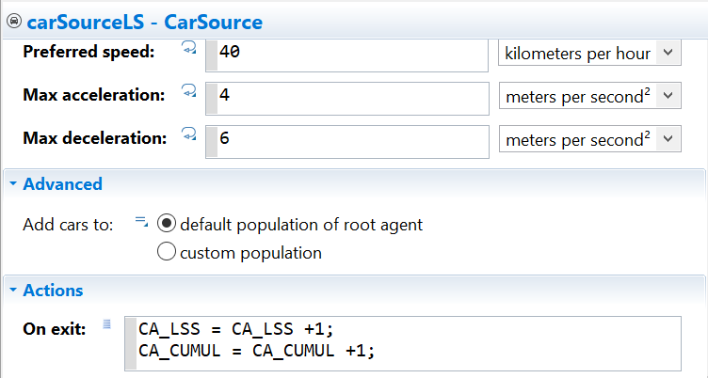

We also computed the mean of the expected number of cars that should enter each road according to our distribution. Where, expected mean = Model time / Distribution.

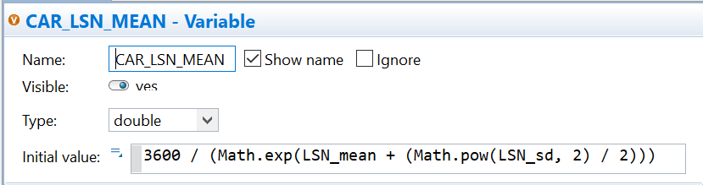

We took the difference of these two values in the experiment and tried to compute the confidence interval.

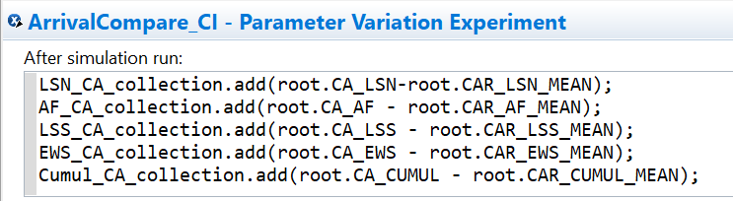

In an ideal case, the output of the experiment should present the confidence interval to include zero. Which would show that the model is actually generating the same number of cars that is expected from the distribution.

**Results**:

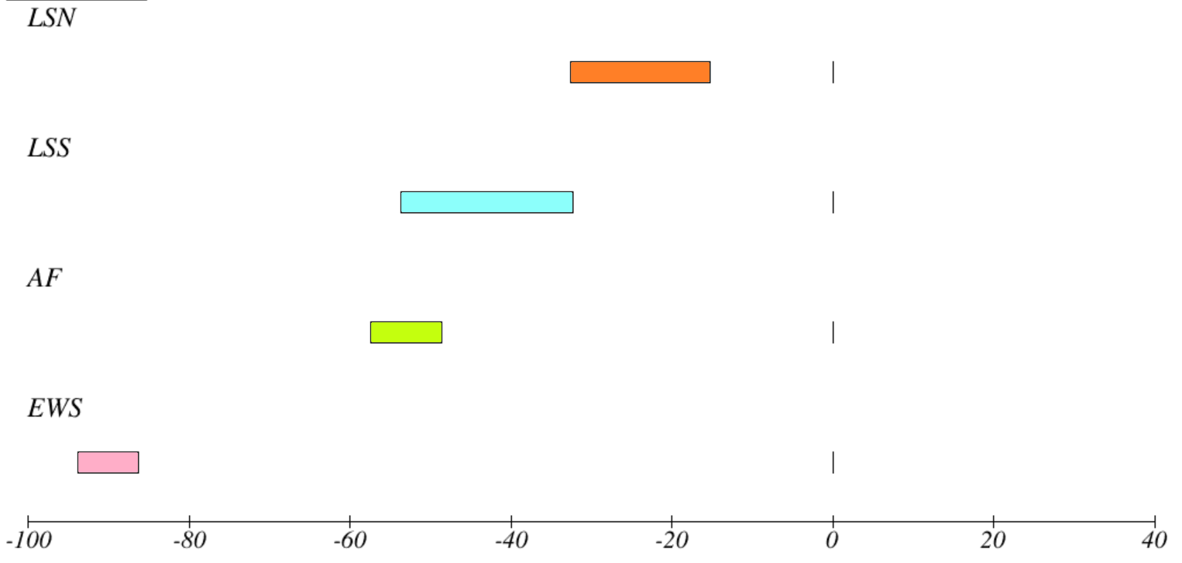

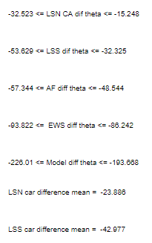

## 2.2 Experiment 2: Sensitivity analysis

This experiment is designed for four roads varying two parameters for each. So in total we have eight sensitivity analysis experiments. As we know that sensitivity analysis is the dependency of output values on input parameters, so here we chose to vary two input parameters, mean and standard deviation of **inter-arrival time**, respectively, for each road. For output, we compute the mean and standard deviation of **throughput** for each road and plot the variation.

For example, the sensitivity analysis of Leipziger Str. North contains changing the mean inter-arrival time from 0.4 to 10 for a step of 0.2, keeping all the other parameters constant.

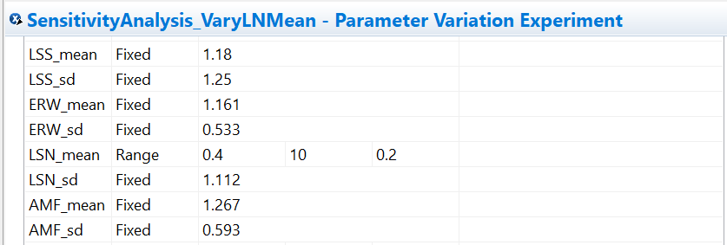

The throughput from the model is the measured output. We are measuring throughput at the sink for each road.

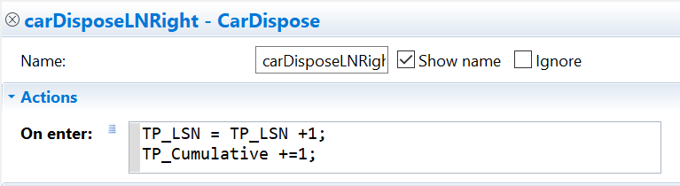

Then the mean and standard deviation of output is computed and plotted against the mean and standard deviation of input.

**Results:**

**Varying EWS Mean:**

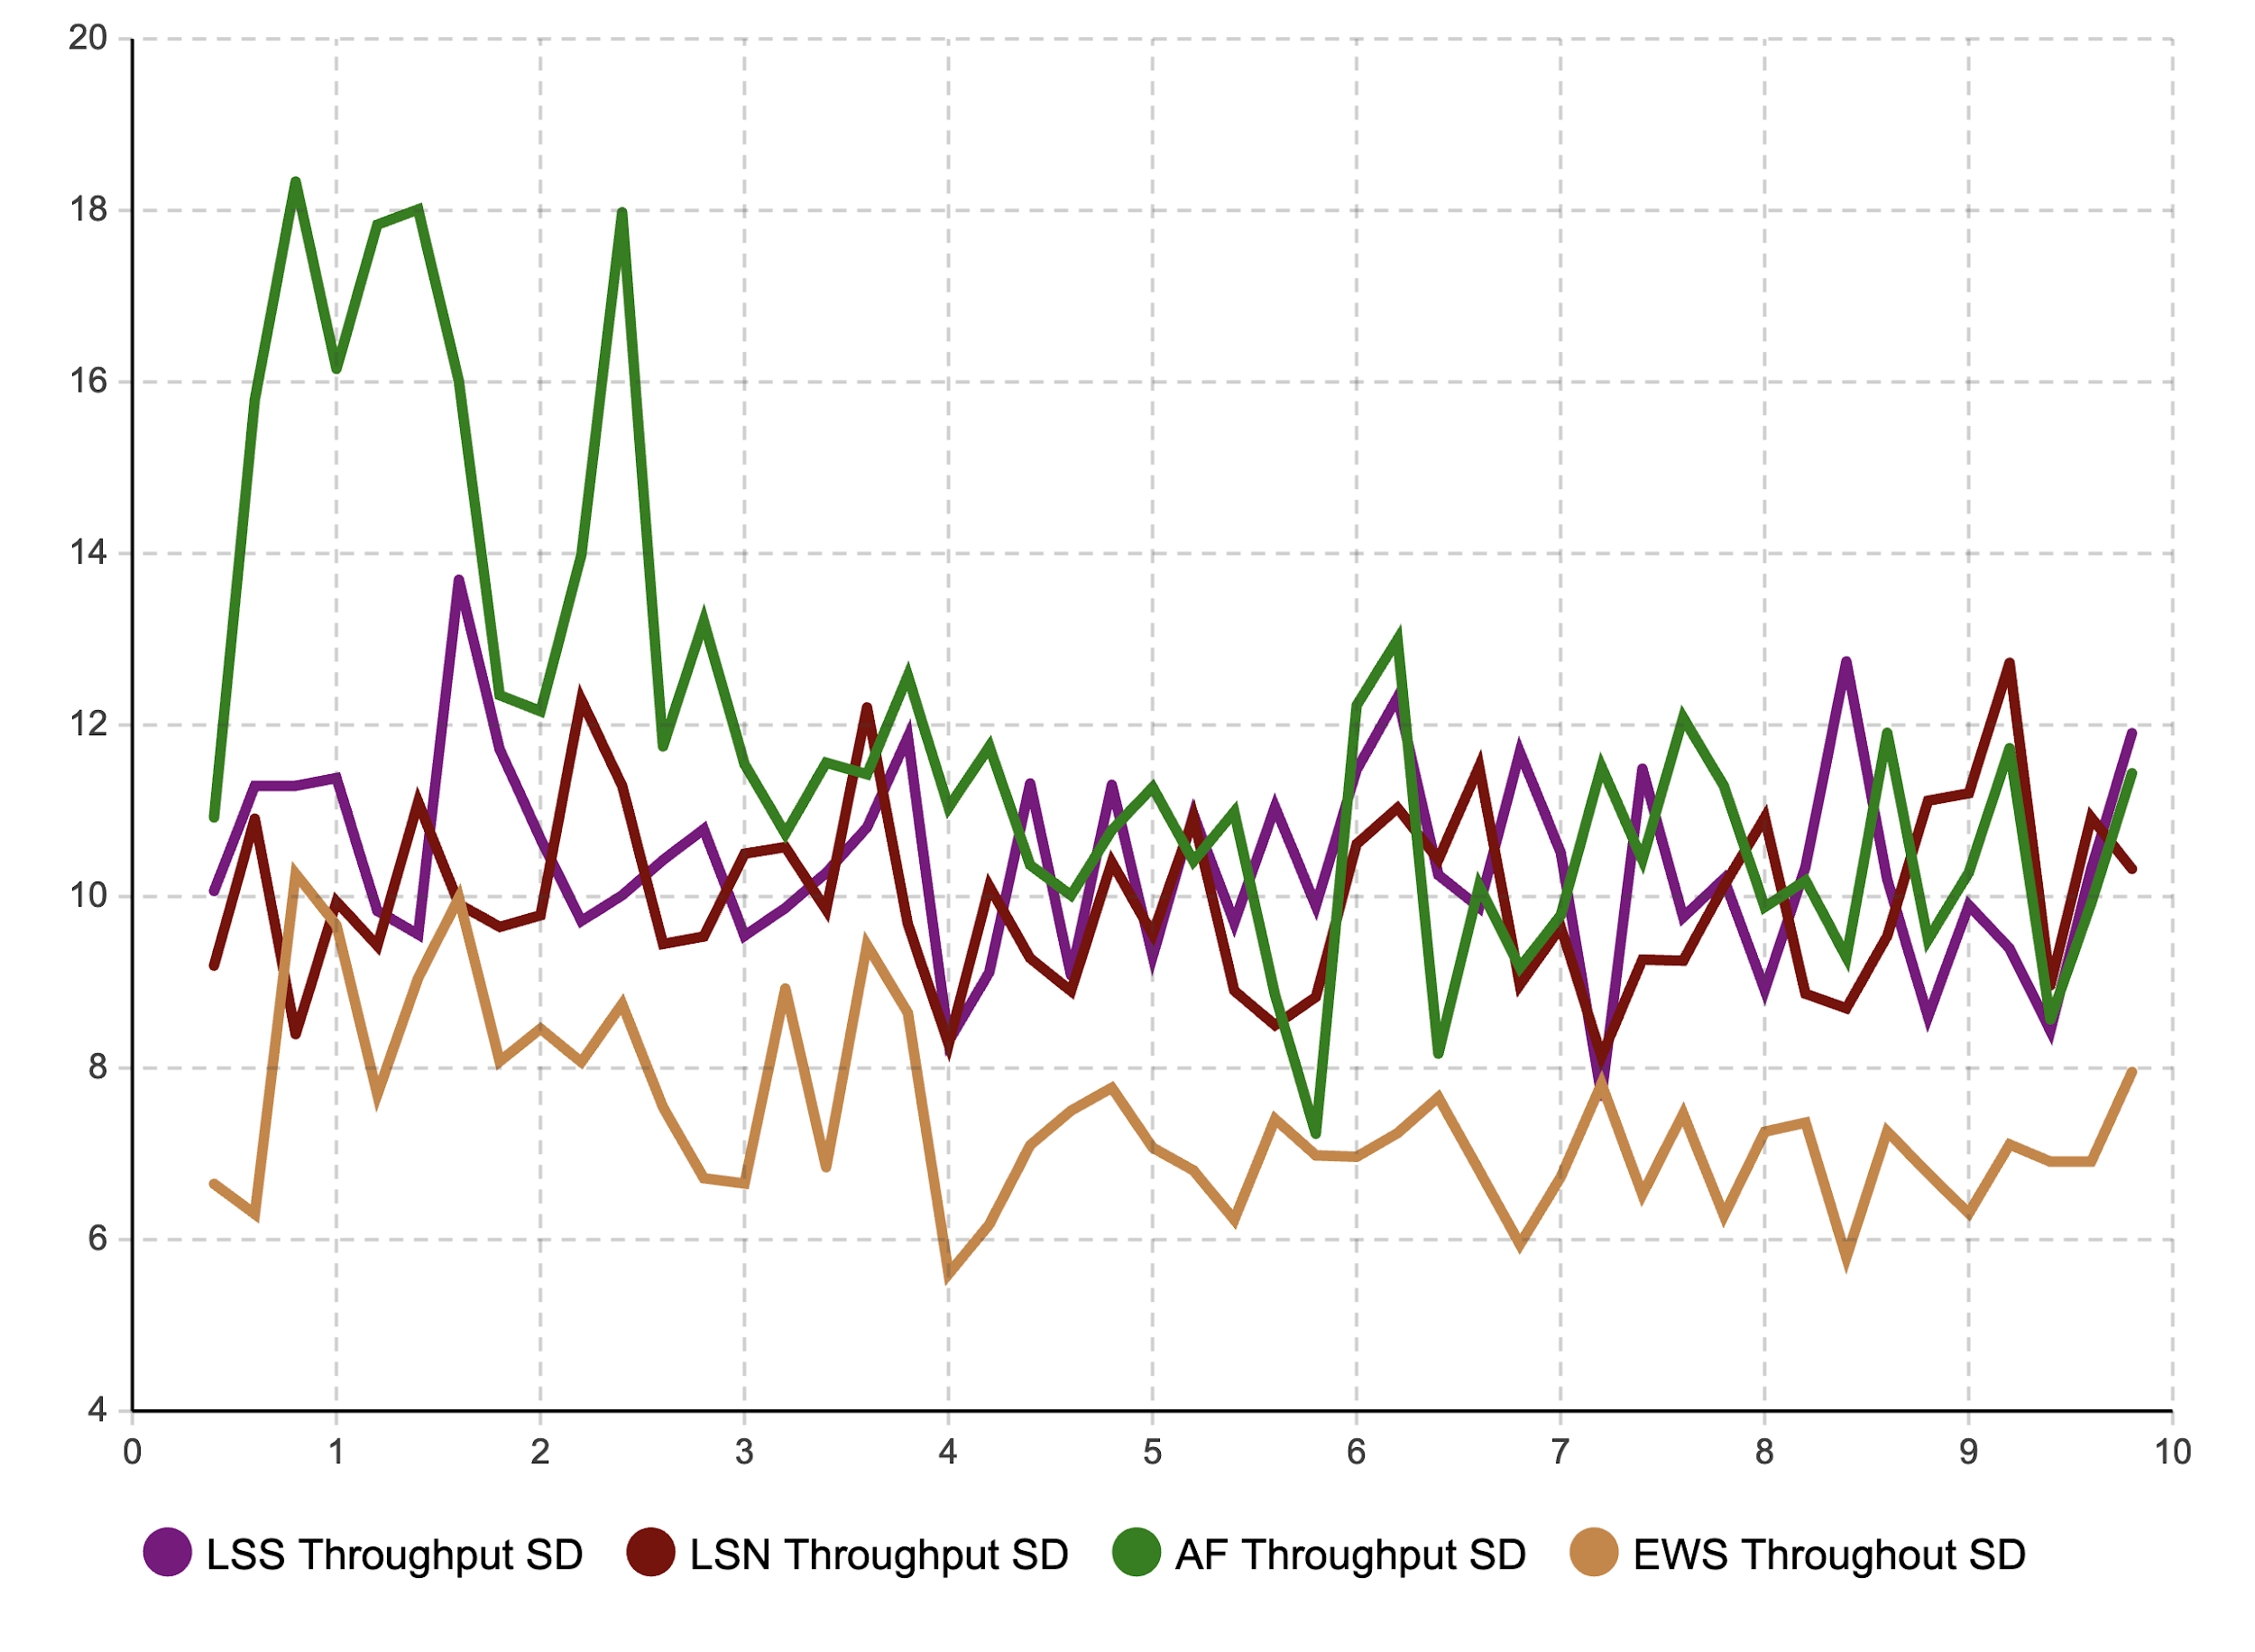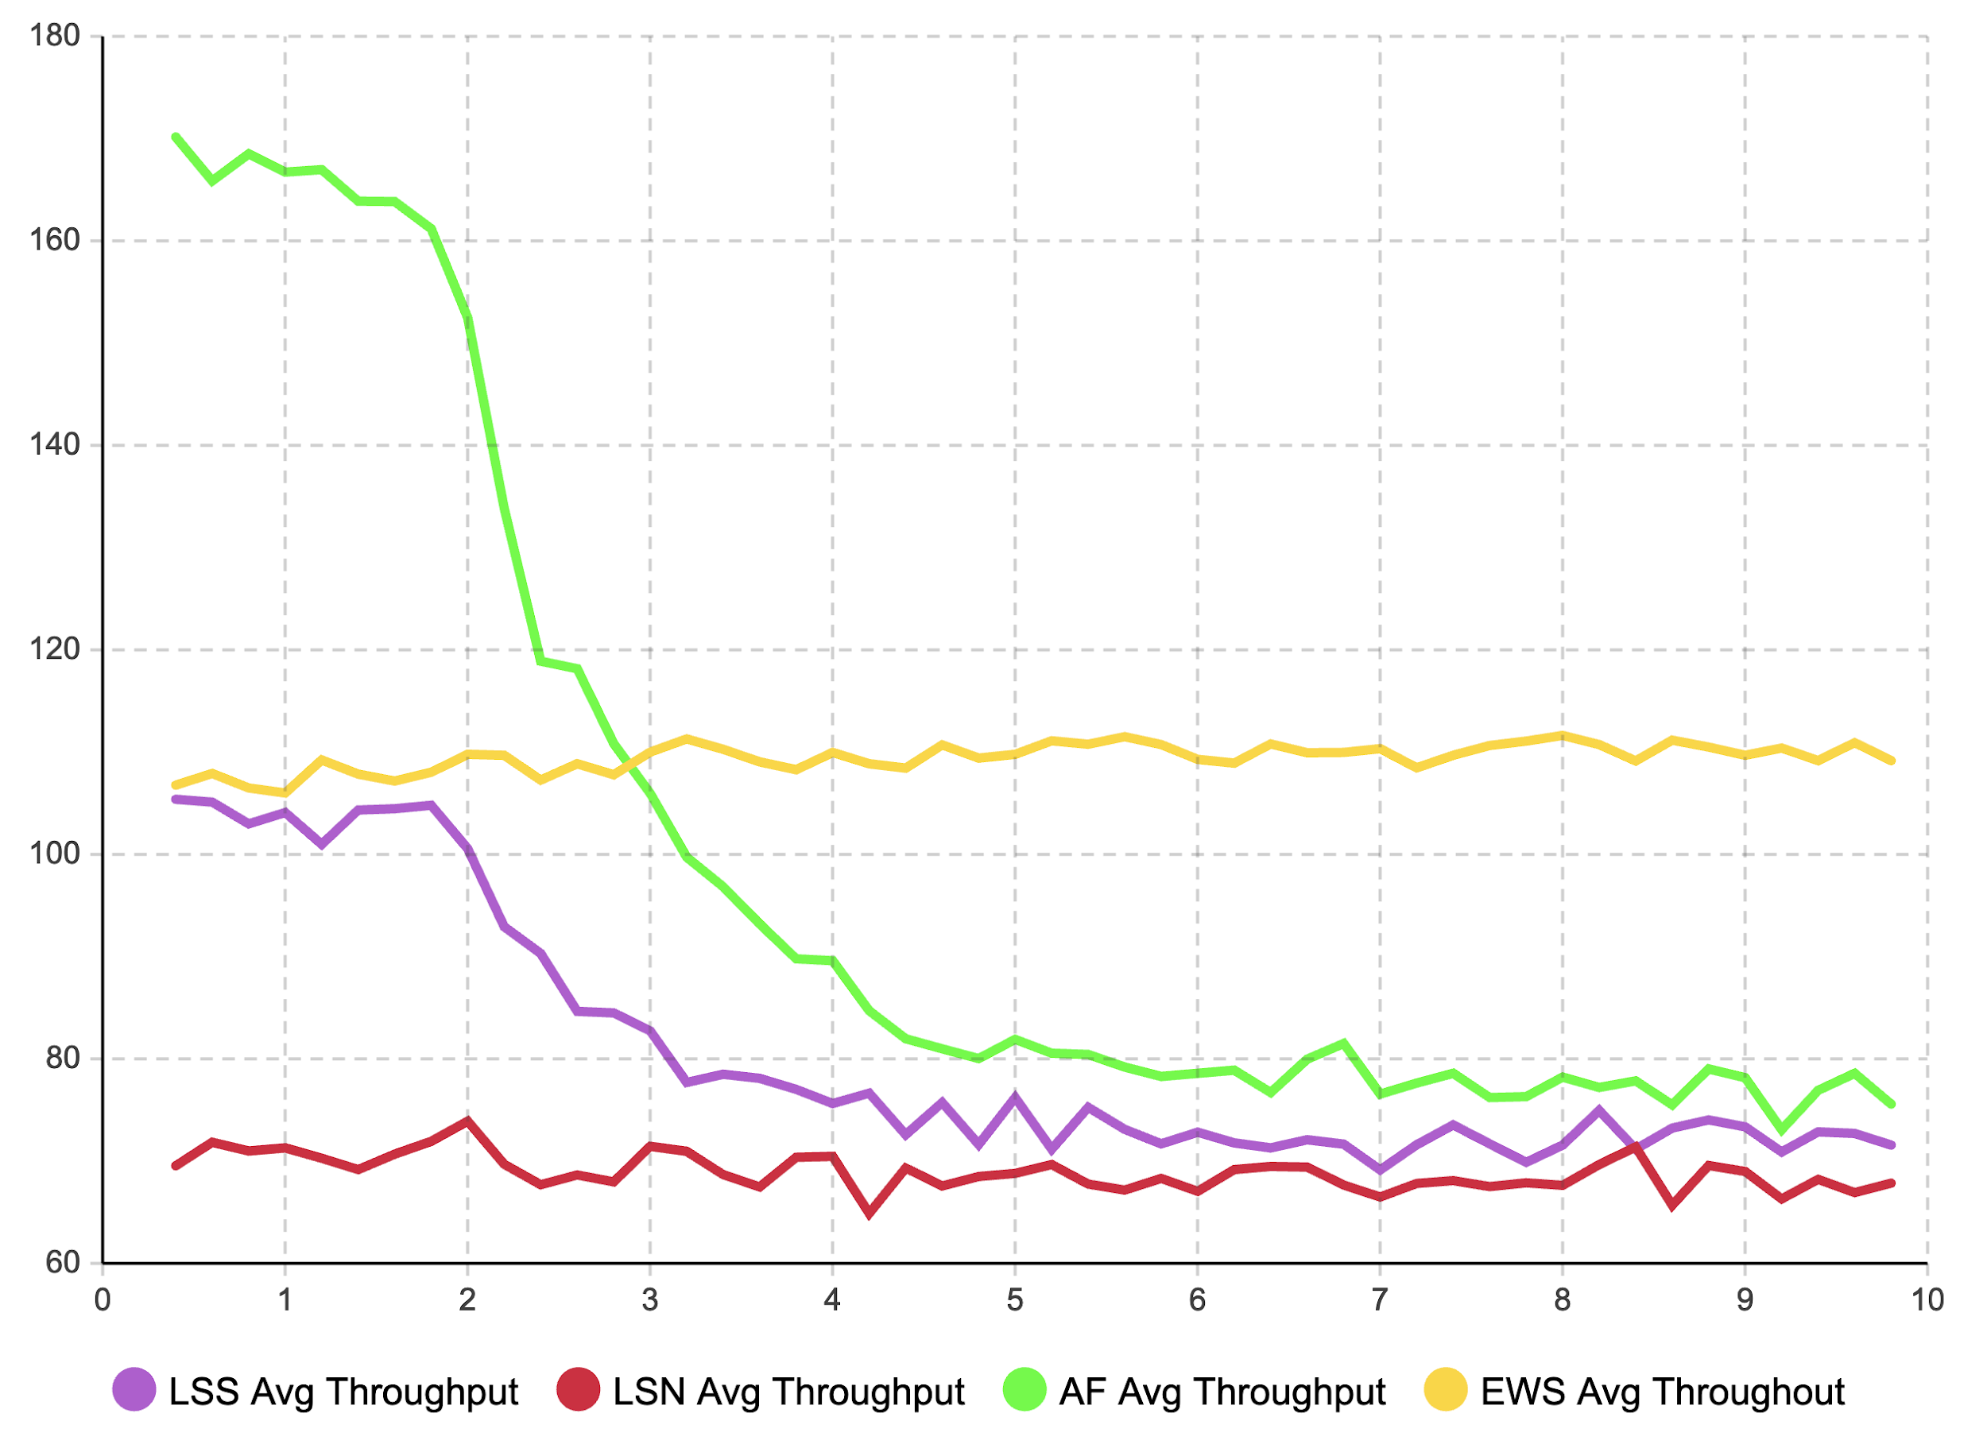

**Varying AF mean:**

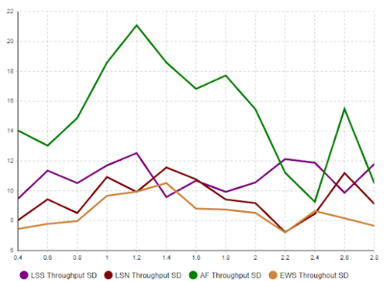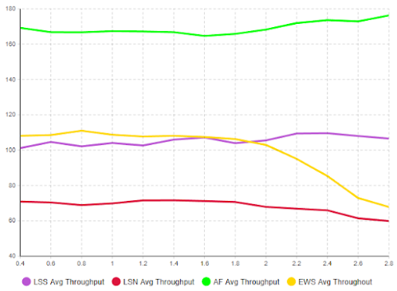

**Varying LSS mean:**

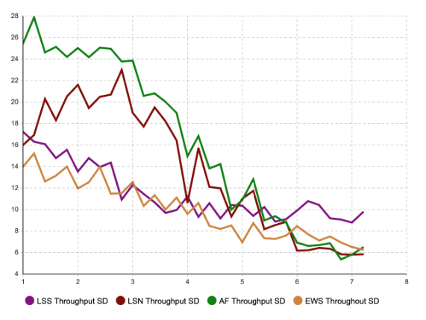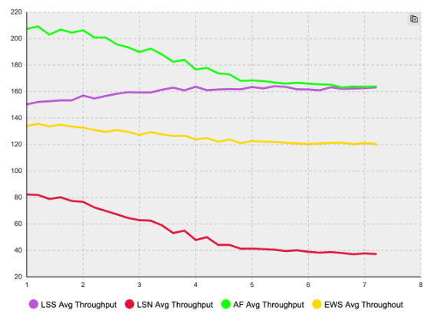

**Varying LSS standard deviation:**

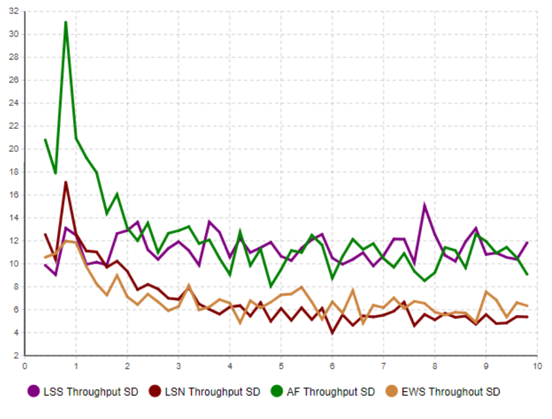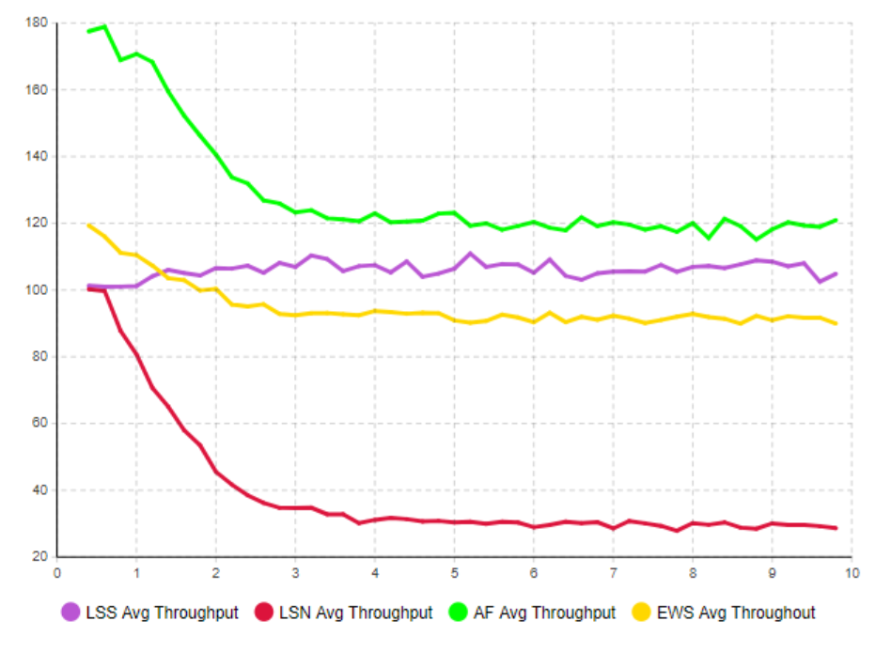

# 3. Any corrections made to your model or data

1. Migrated the system to use variables for all parameters and outputs.
2. We visited the node once again and measured the traffic light duration and updated the model with the latest data.
3. Extended the roads.
4. Since our input data from last year seems unrealistic and doesn’t fit with our distribution, we thought of having a second model with distribution to fit the city of Magdeburg data. But we don’t have inter-arrival time from magdeburg data for the analysis of input data.

# 4. Limitations on the scope of the validity

1. The input data analysis that we made for the model was solely based on the data provided by the team who did the project last year. The data provided by the city of Magdeburg was an older one. So we chose to go ahead with last year’s data since it was recent. But after spending a lot of budget trying to fit the output with last year’s data, we found that the data was not trustworthy.
2. The experiments take a lot of computing power and hence a lot of time to get results and decide on the next step to take.

# 5. Cost overview

The chart in the next page presents a two-dimensional breakdown of costs, aggregated by both milestones and individual members. As planned during Milestone 2, we have already started working on the final documentation to keep it updated with the developments of each individual milestone.

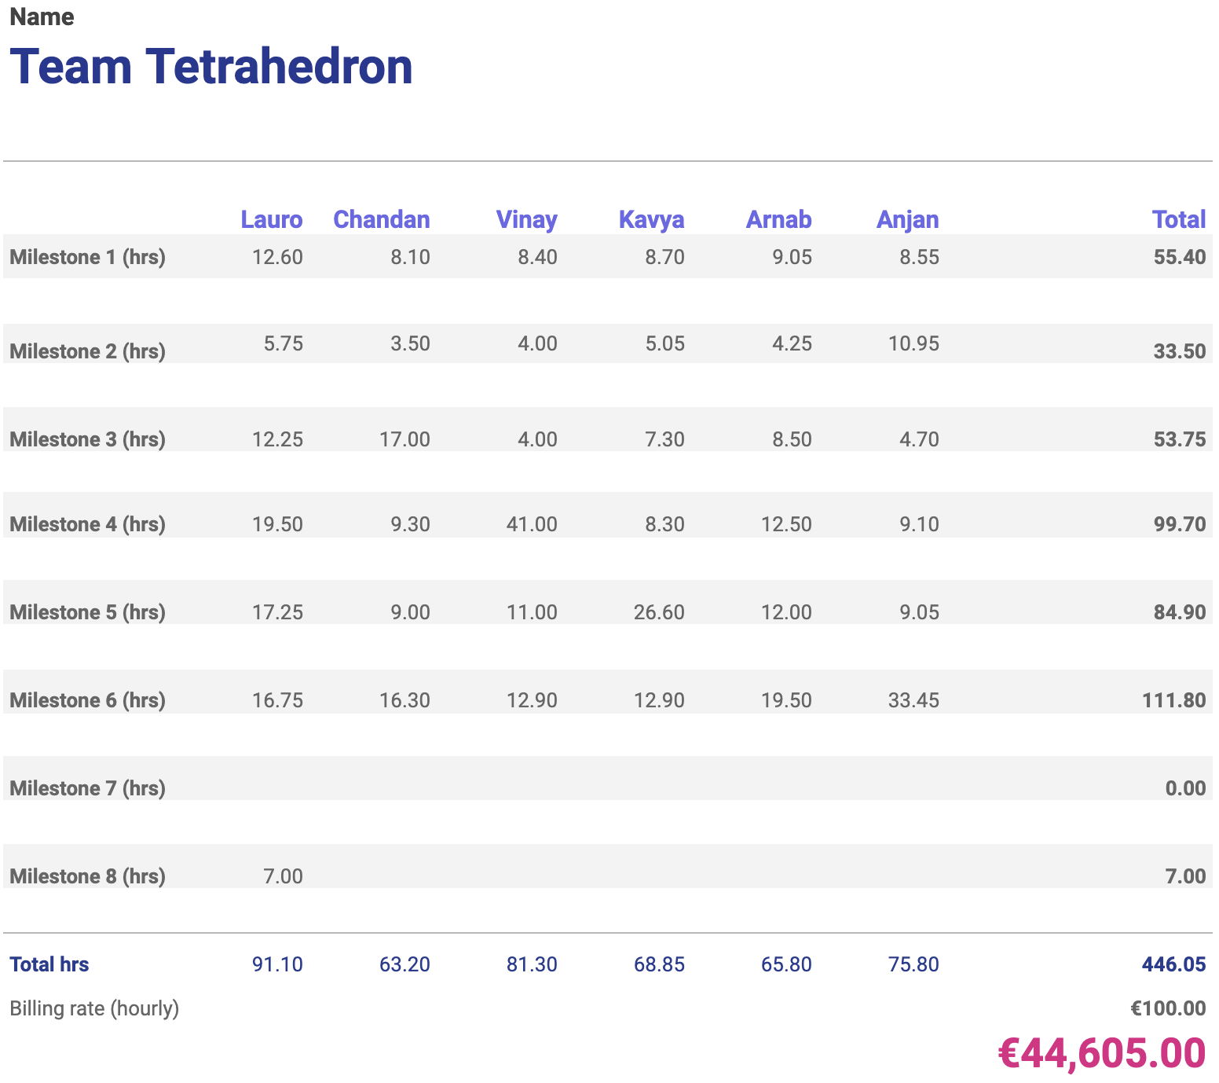

Additionally, the chart below shows the cumulative cost of the project so far. The orange bars represent the planned milestone costs, and the blue line the planned cumulative cost. The green bars represent the actual milestone costs, and the red line the actual cumulative cost.

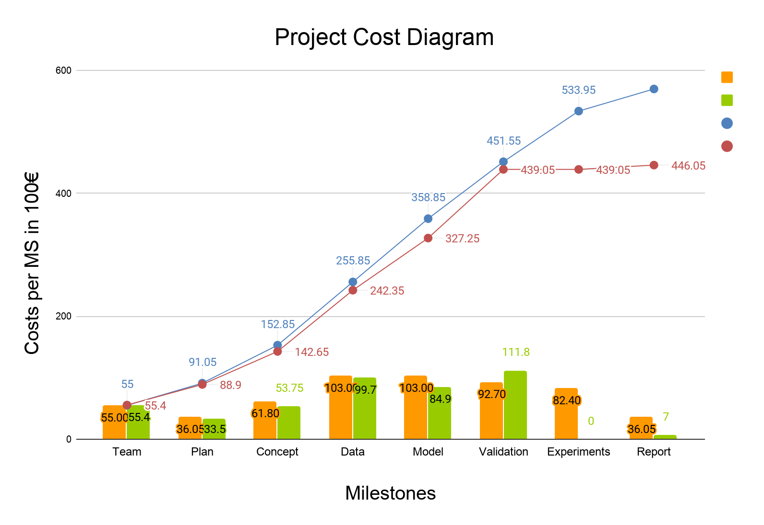

# 

# 6. Future work

We have decided on having two different models, one for our current distribution from last year’s data and the other to fit with Magdeburg data, but we are not sure how to go ahead. Last year’s data seems unrealistic and Magdeburg data lacks inter-arrival time. We are also going to start with the experiments and are working parallely with the final report.